Enhancing Vocabulary Through
iPad Apps
App | Price | Description
Comic Touch | Free | Create comic strips by adding photos and captions using speech bubbles, think bubbles, etc. (iPhone app)
Quizlet | Free  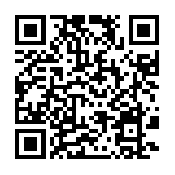 | Use this app to help your students practice vocabulary words using flash cards and games.
Pic Collage | Free | Create a photo collage for a new vocabulary word. Add text and pictures to enhance learning.
StoryLines | Free | StoryLines is an interactive game of “telephone” with pictures.
i-nigma | Free | i-nigma turns your device into a barcode reader. For example, students can scan a QR code made by the teacher to practice vocabulary definitions.
Educreations Interactive Whiteboard | Free | Turn your iPad into a recordable whiteboard. Create tutorials quickly and easily.
App list compiled by Wilber-Clatonia 3-5 grade teachers.

